MIDJOURNEY

THE ETHICAL & UNETHICAL USES

Contents
Introduction 1
What is generative art? 2
How does Midjourney work? 2
Ethical uses of Midjourney 2
1.Brainstorming 3
1.Education 3
3.Event Flyers and infographics: 3
4. Personalized Greetings: 3
5.Improve communication with clients 4
Unethical uses of midjourney 4
Impact on artists 4
privacy 5
Win a prize 5
Impacts on journalism 6
Some risks and how to control them 6
job replacement 6
Opinion 7
Conclusion 7

Introduction

If we told you five years ago that you could conjure any image from your imagination within minutes even if you have never held a paint brush in your life nor possessed any level of artistic skill, would you have believed us? Well thanks to generative AI, now you can! All you need is a few lines of text that describe the image and it will materialize on a computer screen within minutes.
Midjourney is one of the most popular examples of generative AI that can convert natural language prompts into images. Midjourney is owned by an independent research firm with the same name. It is self-funded and closed source and was founded in San Francisco by David Holz. It is only one of many (machine learning-based) image generators that have become publicly available in the past few years.

What is generative art?
Art that is "created when an artist cedes some degree of control to an autonomous system that creates, or is, the art" is referred to as generative art. The history of generative and computer art began in Germany in the mid-1960s. The subsequent evolution of computers, their enhanced processing power augmented further by networked computers and Internet connections, expanded the breadth of what computers could accomplish in the field of generative AI.

How does Midjourney work?
To put the process into simple terms, generative AI uses large language models and diffusion models. Large language models allow it to transform the words in your prompt into a vector, (a numerical version of your prompt) if you will. This vector helps guide another complex process known as diffusion.
In a diffusion model, you have a computer gradually add random noise to its training dataset of images. Over time, it learns how to recover the original image by reversing the noise. The idea is that with enough training, such a model can learn how to generate entirely brand-new images.1
To be able to do so these generative Ais are trained using massive databases, and through a technical process the AI is able to devise new content that resembles the training data but isn’t identical. For instance, after being trained using millions of images of cats that are tagged with the word "cat" the AI is able to produce an image of a cat that resembles the dataset enough that we would have no problem labeling it a cat.
Ethical uses of Midjourney
Using Midjourney is relatively easy, you need to sign up for a subscription as they do not offer a free option, but their lowest monthly subscription is 10 $ a month. A reasonable amount to pay for the services that Midjourney offers.
After signing up, you can use text prompts with parameters to design your image.Parameters are options that you add to your text prompt to control and change the images that Midjourney generates. You can choose things like image weight (how close the generated image has to be to your text prompt), aspect ratio and the level of styling to name a few. Their website offers a complete list of parameters to aid you in your creative process
1.Brainstorming
Artists and designers can use Midjourney to brainstorm ideas and styles reducing the time and resources needed before deciding on the final look and feel of the art piece or product.
For example an artist tasked with creating a celtic princess illustration can attempt different art styles, different poses and colour schemes before committing brush to canvas to create his art piece.
1.Education
Teachers and educators can utilize Midjourney to create adaptive learning resources that aid in tailoring educational content to individual students' needs, promoting personalized and effective learning experiences.
2. Presentations
The visual design of slides in a presentation is a key factor in engaging the audience, be it for work or school. Midjourney can help in designing visually appealing slides for presentations to enhance the overall impact.

3.Event Flyers and infographics:

Midjourney can help in designing flyers or infographics for events, conferences, or workshops. This can be valuable to small businesses, charities, and activists to help them in attracting an audience.
Many of these don’t have the funds to hire professional designers to create these fliers or infographics. Using Midjourney allows them to get their message across or to attract visitors and doners.

4. Personalized Greetings:
At an age where almost all our pictures and videos are in digital form, Midjourney can make custom images for birthday cards, holiday greetings, or other personal messages. The extra effort makes the occasion more memorable, more personal as it allows you to use your own personal custom designs as opposed to mass produced commercial ones.

5.Improve communication with clients
When discussing a new product, be it a building design or a campaign ad, midjourney can aid in giving clients a visual representation of the ideas being discussed.

Unethical uses of midjourney

While we have discussed the ethical uses of midjourney, we will discuss some unethical uses, including:

Impact on artists
Artists develop their talent by training over the years, taking courses, and spending time and materials to buy educational books. Companies like this company use their work without permission and make millions.
Now it is possible for anyone to create thousands of images in a short time to create a project or children’s book. On the other hand ,artist will take a longer time to do the same job .
Digital artwork forgery in the context of image generates being trained using billions of image text pairs obtained from the Internet . it highlights that artists have reported being approached by companies producing image generates to work on modifying the outputs of their systems . additionally, it mentions that the pursuit of art could be relegated to the independently wealthy and those who can afford to develop their artistic skills while working a full-time job disproportionately harming the development of artists from marginalized communities.
Open ai and Google research acknowledge their own gender and a racial bias with a prompt for nurse and assistant showing all women and boys showing all white men .ai art has already been used for magazines covers including cosmopolitan ‏ (figure 1).
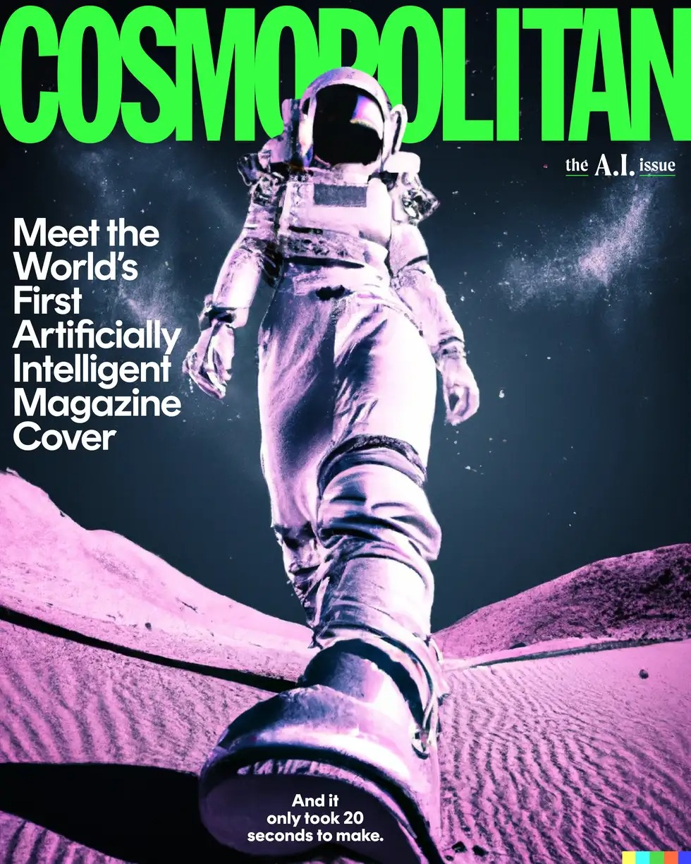
figure 1 : cosmopolitan ‏cover
This actually led to many artists losing their work like Netflix Japan using image generators for animation .blaming " labor shortage" in the anime industry for not hiring artists.

privacy
The AI requires access to sensitive data to function effectively, but this raises concerns about who controls this information and how it is used. Furthermore, there is the fear that reliance on AI like Midjourney could erode personal autonomy, as individuals and organizations might defer to the AI’s suggestions without critical evaluation.

Win a prize
An award-winning piece of art cannot be protected by copyright, this is what the US Copyright Office said after the application was used by Matthew Allen. Matthew Allen took the image from the midjourney application and made 624 edits to it using Photoshop until he submitted it to a competition and won his painting ‏Théâtre‏ ‏D'opéra Spatial‏ (figure 2) First place, but it was not an original work, so the government agency issued its decision that the work was not eligible for copyright.
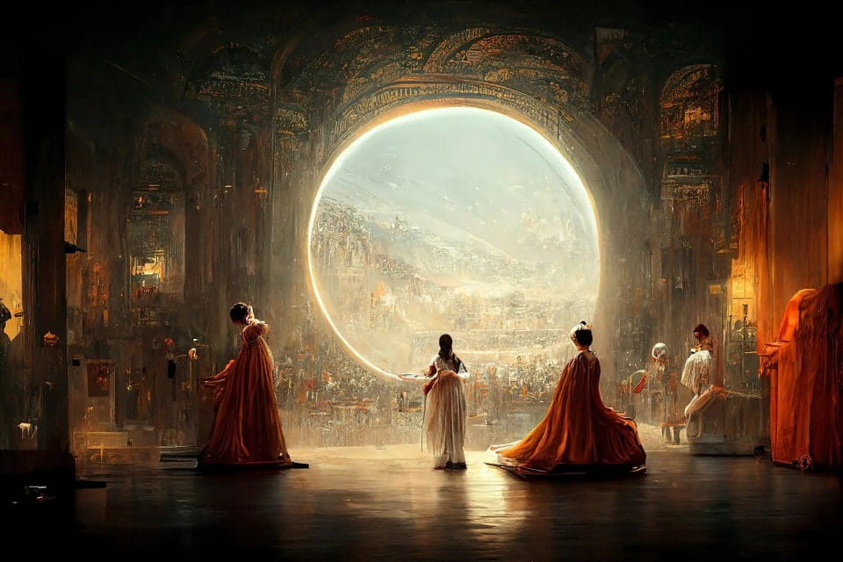
Figure 2 : Théâtre‏ ‏D'opéra Spatial by Matthew Allen

Impacts on journalism
Some journalists see midjourney as a useful tool and others believe its use is a potential threat. In the world of visual content, it is important and has a greater resonance. Its use complicates the ability of fact-checkers to verify the authenticity and accuracy of images. It is easy to deceive the eye. For example, images of politicians have been used to spread false information. 2023 Fake photos of former President Donald Trump spread, showing that he was arrested by the New York Police.
It has become difficult to distinguish original content from fake content

Some risks and how to control them

job replacement
there are some recommendations to protect Artists:

- Legislation to allow using Al-derived imagery strictly for reference purposes and making it unacceptable to hand over a fully Al-generated work as a finished concept.
- Proposals for a metric to quantify the amount of human interaction with an image generator to determine whether a generated image is copyrightable, with a 25% or less interaction level being uncopyrightable.
- Advocacy for regulations that prevent organizations from using people's content to train image generators without their consent.
- Funding for Al research that is not entangled with corporate interests.
- Task-specific works in well-defined domains that serve specific communities.
- A computer science education system that stresses the manner in which power interacts with technology.
These recommendations aim to address economic loss and the use of artists' work for training image generators without their consent or compensation.

Opinion
In my opinion, I believe we can use midjourney to help us develop our talents and create images. We can use it in many fields, and I do not think that it will cause the replacement of humans. Rather, it will be used to improve human productivity in the field of art.

Conclusion

Some may not agree with what specialists in the field of artificial intelligence are proposing, especially in the field of art, and the debate may remain between artificial intelligence and art for a long time, and someone may say that manual work with a brush and colors is art, and that digital work is actually fake, but no one has decided. This matter. This debate, the artist whose sympathy will remain, and intelligent art will not become an advanced version of manual art, but rather will preserve it because it is his site and his fans.
In this paper, We discussed one of the artificial intelligence tools, which is the midjourney application, which is used to generate images. We talked about how it works and how to use it, and we summarized the ethical and immoral uses of the application that affect human life. We mentioned some potential risks of using it and how we can control them.

